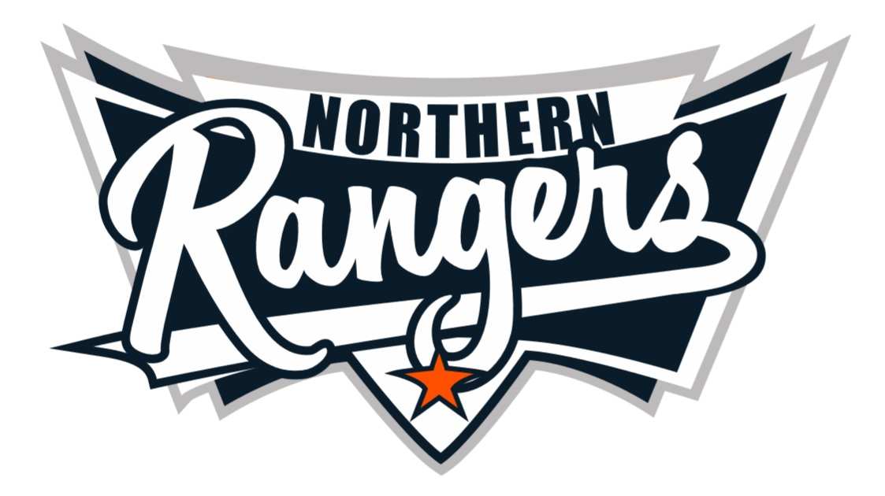

**2025 NORTHERN RANGERS COACHES ANNOUNCEMENTS**

**Thank you to all applicants and CONGRATULATIONS.**

**TRIAL 1: Venue/Date - TBA (1st Mon/Wed following completion of Autumn comp)**

**TRIAL 2: Venue/Date - TBA (1st Mon/Wed following completion of Autumn comp)**

**Tournament/Coaching & Trial Info will be emailed to coaches soon.**

**Player nominations will open 28th May!**

**20s WOMENS – Coach: Steve Corbett**

**OPEN MIXED – Coach: Geoff Sharpe**

**30s/35s MENS - Coach: Lewellyn Sankey**

**37S WOMEN – Coach: Mel Watson**

**Assistant Coach: Jock Stier**